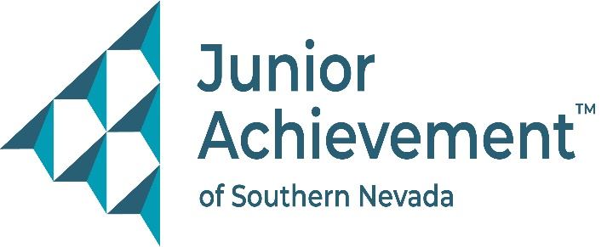

Date
FOR IMMEDIATE RELEASE:

Junior Achievement of Southern Nevada Welcomes Crystal Hirschi from
Hirschi Companies to Board of Directors



LAS VEGAS - Junior Achievement of Southern Nevada (JASN) is excited to announce the appointment of Crystal Hirschi, executive vice president and co-owner of Hirschi Companies, to its board of directors. With a dynamic background in construction, education, and community development, she brings a wealth of experience, leadership, and passion for empowering future generations through financial literacy, workforce development and entrepreneurship.

As a key leader at Hirschi Companies, a premier construction firm in Southern Nevada and Phoenix Arizona, Hirschi oversees marketing, community engagement, and strategic planning. She has played a pivotal role in the company’s growth and ongoing community involvement, including workforce development initiatives such as Pathways in Vocational Village. This innovative program equips incarcerated individuals with skills in masonry and offers them a fresh start and career path upon release.

Beyond her professional achievements, Hirschi’s commitment to community service and humanitarian work is profound. She is a passionate advocate for education, having served on several boards and as chairwoman of the City of North Las Vegas Education Advisory Board. She also leads Hirschi Helping Hands, a branch of her company dedicated to making a positive impact in the local community; and her dedication to humanitarian causes has taken her around the world, where she has built schools, provided resources to fight human trafficking, and advocated for human rights

"I believe that education and opportunity are key to breaking the cycle of poverty," said Hirschi. "Junior Achievement’s mission aligns with my passion for empowering young people to take control of their economic future. I’m excited to contribute my skills and experience to this incredible organization."

Hirschi’s board service also includes Libertas International, HomeAid Southern Nevada and Construction vs. Cancer, where she chaired the effort raising significant funds for pediatric cancer research. She also has helped Choice Humanitarian and Days for Girls.

"We are thrilled to have Crystal join our board," said Michelle Jackson, president and CEO of the financial literacy nonprofit organization. "Her passion for education, community service, and empowering future generations will bring invaluable insight and leadership to our team as we continue to grow and expand our programs for young people across Southern Nevada, particularly with the opening of our new Junior Achievement of Southern Nevada Inspiration Center."

About Junior Achievement of Southern Nevada
Founded locally in 1996, Junior Achievement of Southern Nevada, Inc. is dedicated to providing financial education to K-12 students and young adults with a curriculum including wants vs. needs, budget management to economic principals, workforce skills, credit and entrepreneurship. The completion of the new 40,000-square-foot Junior Achievement of Southern Nevada Inspiration Center will allow the nonprofit organization to impact more than 60,000 local youth. It is now the permanent site for capstone programs, Betty’s JA BizTown and JA Finance Park. Junior Achievement of Southern Nevada’s financial literacy mission is accomplished with the support of 285 businesses and 6,800 business role models, who help youth learn about the “business of life,” by helping bridge the gap between what youth learn in school and the real world. For more information visit https://jasnv.org/ and follow on Instagram and Facebook.

About Junior Achievement USA® (JA)
Junior Achievement is the world's largest organization dedicated to giving young people the knowledge and skills they need to own their economic success, plan for their future, and make smart academic and economic choices. JA programs are delivered by corporate and community volunteers, and provide relevant, hands-on experiences that give students from kindergarten through high school knowledge and skills in financial literacy, work readiness and entrepreneurship. Today, JA reaches 4.5 million students per year in 115 markets across the United States, with an additional 5.8 million students served by operations in 120 other countries worldwide. Visit www.ja.org for more information.

# # #
MEDIA CONTACT:
Nancy Katz, Purdue Marion & Associates, 702-349-0063 or nancy@purduemarion.com

